Introduction
Distributed Denial of Service attacks, or DDoS attacks are attempts to make digital infrastructure unavailable by flooding them with requests from multiple sources. A malicious user infects other devices, allowing the user to control them. When all infected devices flood the same system, the system breaks down, and ordinary traffic is unable to reach the desired system. One of the most famous DDoS attacks was in 2016; more than a million devices attacked DNS provider Dyn, resulting in major online services like Netflix, Airbnb, and the BBC being cut off. More recently, social media service Bluesky was attacked for 24 hours on April 15th by a pro-Iran hacktivist group.
Incidents like these show the relevance of protection and detection of DDoS attacks. Distributed Denial of Service attacks are (one of the) most common network security threat experienced by Enterprises, Governments and Educational bodies, while the customers of Service Providers (e.g. ISPs and Data Centers) remain to be the number one target of DDoS attacks [arbor networks]/ while network-layer attacks target vital Internet structure [cloudflare report]. DDoS attacks are easy to execute, even without technical knowledge [netscout]. AI integrated attacks and increasing sophistication only prove that DDOS attacks are becoming more dangerous: A record of 31.4 terabytes per second attack has been stopped by Internet-service provider Cloudflare [cloudflare].
Due to the relevance of DDoS attacks, many researches have been conducted on detection, defending, and mitigating attacks. In this research, we investigate the severity of a DDoS attack on its societal impact, where we use Google Alerts as a source to identify DDoS attacks.
Wat is er al onderzocht
- Problem statement
We weten niet wat DDOS aanvallen impactvoller/interessanter/populairder maakt tegenover media.
- Goals/objectives
Annotated (expanded) Google alert related dataset
Vergelijking van impact op verschillende dimensies van PESTEL, hier een Schaal van belangen aan zetten, gebaseerd op dataset
Tool om inzicht te genereren in impact van DDOS aanval aan de hand van dataset
- Research question
RQ1: What is the impact of PESTEL dimensions on the news popularity of a DDOS attack?
RQ2: How do we create a measurement tool to contextualize/visualize the impact (based on the annotated dataset)?

Methodology and approach
Dataset is already collected. Is collected via collecting Google alerts about DDOS or Distributed Denial Of Service for a long period of time (since 2018(?))
Dataset is annotated via tool of Wim Kamerman
Qualitative analyzation of dataset on PESTEL dimensions occurring, of occurred give quantitative metric
Will use Python, local LLM, to help code, use Machine learning models for text annotation

Work programme
- Tasks and results
Tasks:
Give PESTEL value to dataset
Create tool to gain insight into ‘value’ of alerts about DDOS
- Timeframe
Proposal: 2 weeks
Setup: 1 week
Dataset annotation: 2 weeks
Tool creation: 3 weeks
Slack: 2 week
Presentation: 1 week
- Schedule (Gant chart)
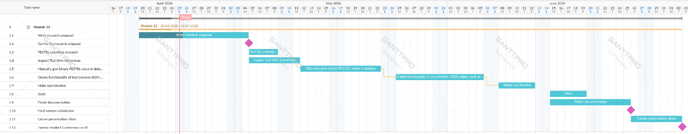

Notities over onderzoek:

Groter onderzoek: Socioeconomische invloed van DDOS aanvallen (in bedrijven)
Specifieke opdracht: Gebruik ‘Text classification’ (Machine Learning) (ga ik zo meer over opzoeken) om specifieke event te filteren (op een gegeven dataset).

Machine learning op DDOS (link)

Notities meeting 1:
Abhishta is weg van 26 tot 6, JW van 8 tot 29
JW gaat over go/no go van 4 mei
Goal: Create artifact (system, dynamic) to be able to understand/interpret/visualize/quantify severity of DDOS attack on PESTEL dimensions
Context: Study has been going since 2018. Because cyber attacks can be a big problem, we want to measure severity/impact of DDOS attack on political, economical, social, technical, environmental en legal dimensions. We have collected a large database of google alerts, which are notifications of news articles about DDOS/Distributed denial of service attacks. We want to see trends, be able to identify incidents, and quantify impact. We want to know: What makes an attack ‘popular’ for media to report on. In other words: Make the data usable for people who want to understand/visualize/contextualize the severity of a DDOS attack.
Dataset:
Json met als attributen {Web/News; Date (onbekend format), link, Content, Content_NER (?), Content_Title, Content_Title_NER, Cat4_id, cat4_name (research, attack, other, arrest), cat2a_id, cat2a_name (research, attack, other, arrest), Content_body, Content_body_NER, Content_Double_Title, Content_Triple_Title, Content_Triple_Title_NER, Content_Double_Body}

Bronnen ofzo idk:
https://blog.cloudflare.com/defending-the-internet-how-cloudflare-blocked-a-monumental-7-3-tbps-ddos/
Wisman, R. (2025, 25 november). DDoS-bescherming Trendrapport 2026: AI-aanvallen en recordvolumes domineren. DataWeb B.V. https://www.dataweb.nl/ddos-trendrapport-2026/
Arbor Networks. Worldwide infrastructure security report- volume xii. (2016). Retrieved: June 29, 2018 from https://pages.arbornetworks.com/rs/082-KNA 087/images/12th Worldwide Infrastructure Security Report.pdf, 2016.
NETSCOUT DDoS Threat Intelligence Report / July 2025 to December 2025
https://blog.cloudflare.com/ddos-threat-report-2025-q4/

